1:

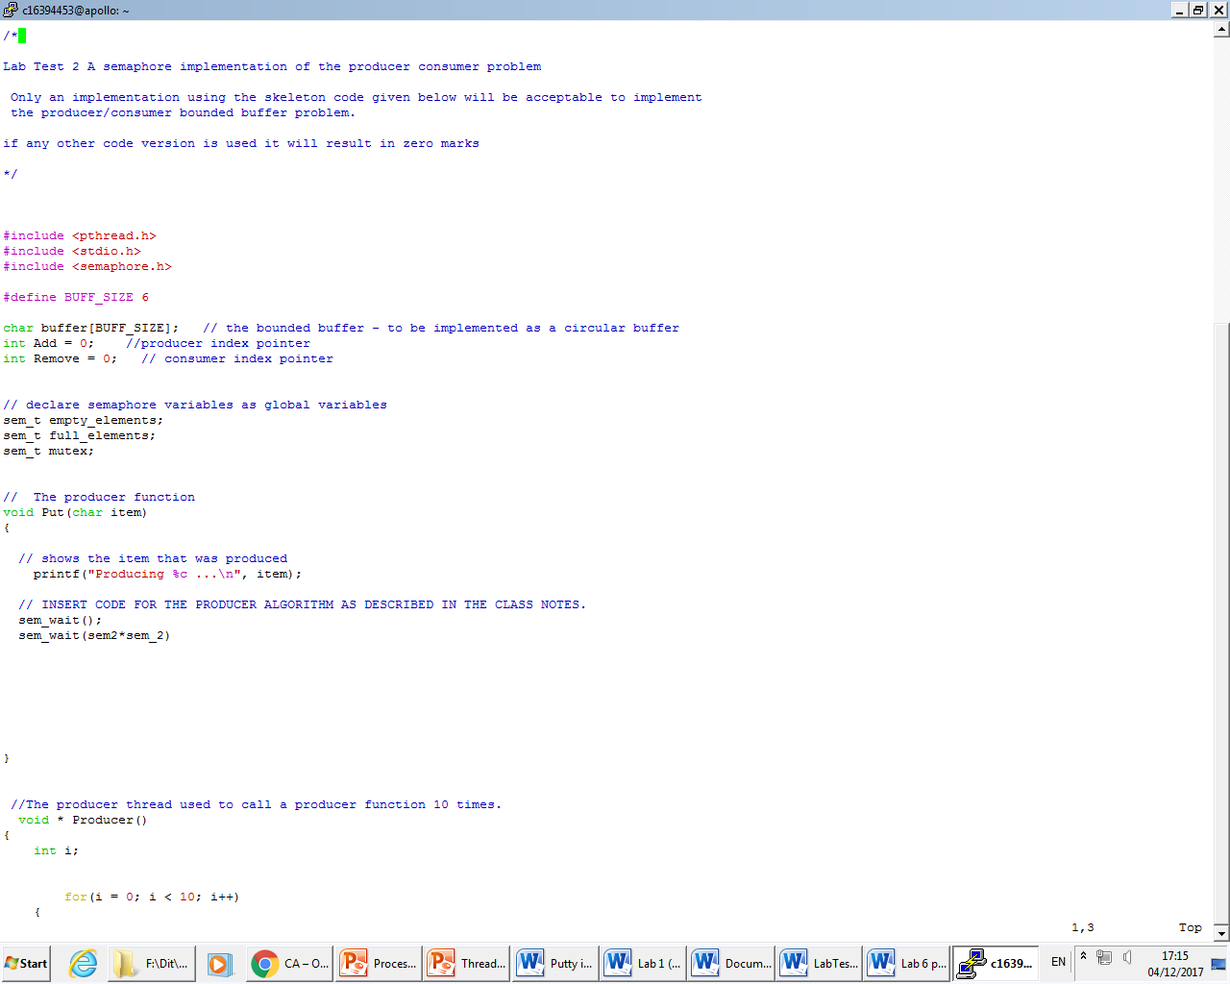

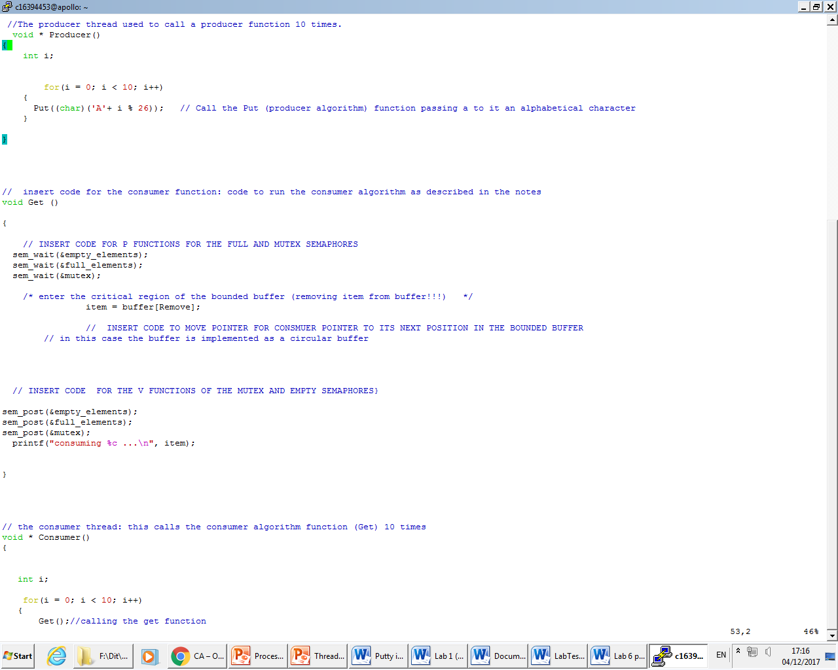

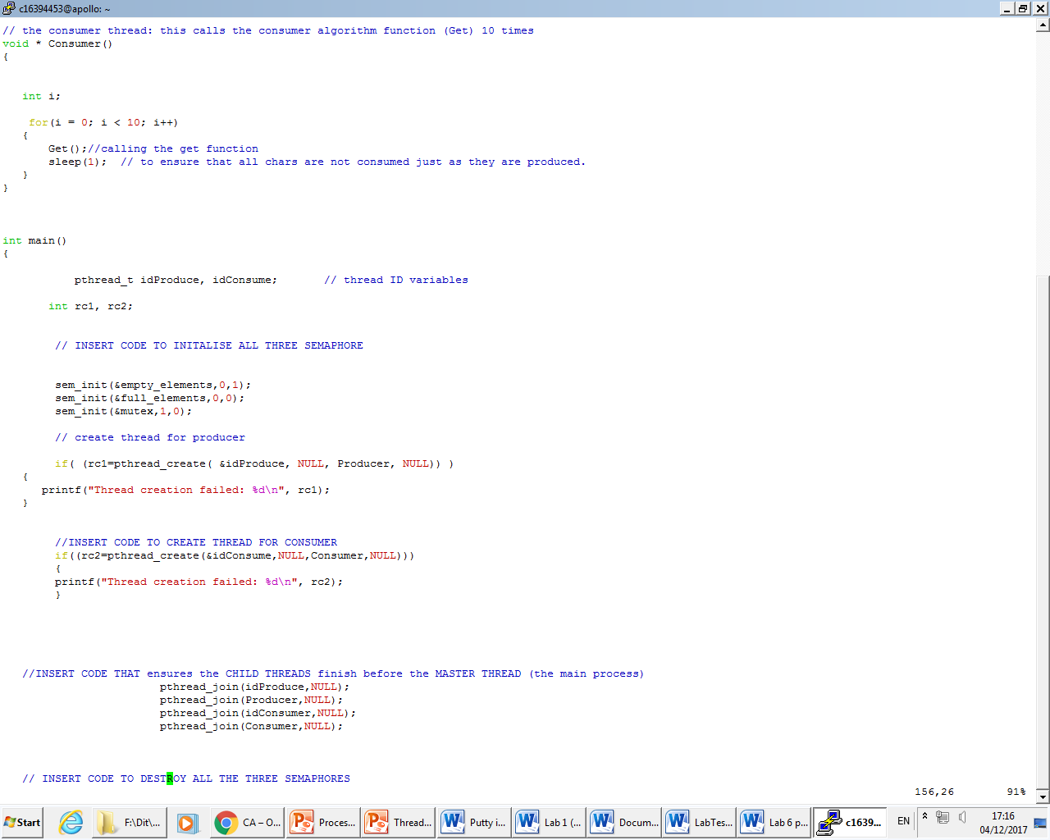

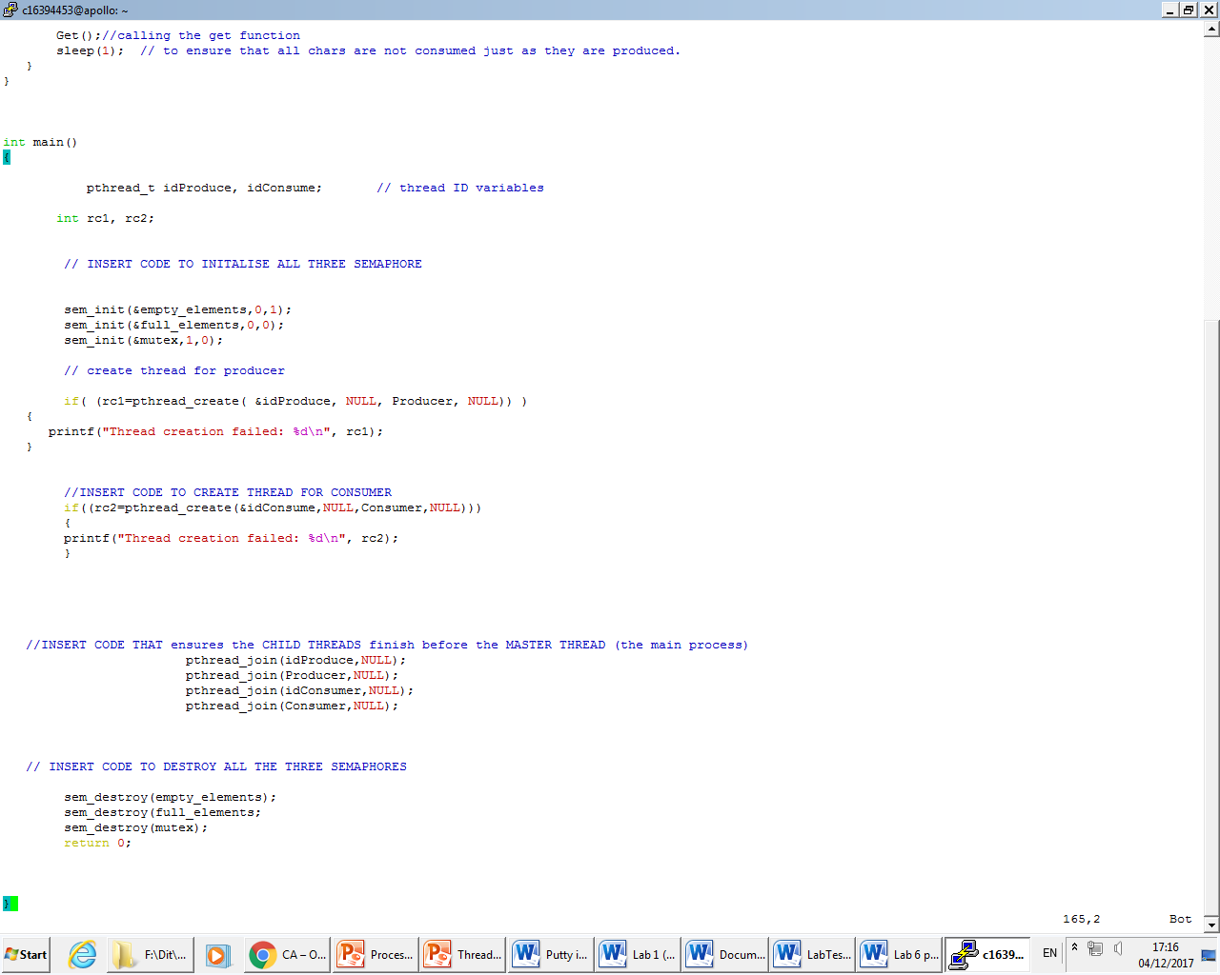

3:

Explanation:

My code isn’t going to work as the code itself is not running. The expected output should go in sequence of A to J being produced by the consumer and the producer. The reason why as we can see in the code the for both the producer and the consumer functions they are called ten times each from the threads.

As we can see from the correct output that the consumer and the producer are being outputted in sequence but they are not being produced one after another. You could run it multiple times and still get a different sequence. This is for where the threads can be produced.

We can see that the semaphores are working as intended. The P idea in semaphores is the wait function. The program waits until the semaphore calls to say that it is safe to enter the critical region. This is represented by the mutex being empty. When the signal is called V it enters the critical region. When it exits the critical region the mutex is full and the consumer and again it is called to enter the critical region but this time reads the buffer(mutex), exits the critical region and emptys the mutex by signalling V. The process repeats 10 times for each. This allows the producer to enter data to buffer and consumer to delete